**UniFile**

**Project Document**

Chandler Bullock

Jeff Swarts

Kristopher Maxwell

System Requirements

* Locally hosted Web Server
* A Database with the schema ‘unifile.sql’ uploaded make sure your localhost username, password are the same as the database connected to in DatabaseHelper.php
* Best on screens larger than 720p
* Best compatibility with Google Chrome browser

Product Functionality

UniFile is a web based file management solution. It helps students, TA’s, and professors keep track of and navigate through their files with comprehensive filters. Each file is connected to a specific section of a course and thus can be easily shared with professors of the course, and professors can easily share files to all students participating in that section. Students will also be able to share files with other students for easier collaboration in group projects. Files can be managed with many criteria such as file type, date, file name, and the original owner of the file. In addition to helping users organize their files, UniFile is a great resource for students who need to later create a portfolio as all their projects and assignments will be in one place, and when the product launches these files would be accessible from the cloud.

Entity Relationship Design

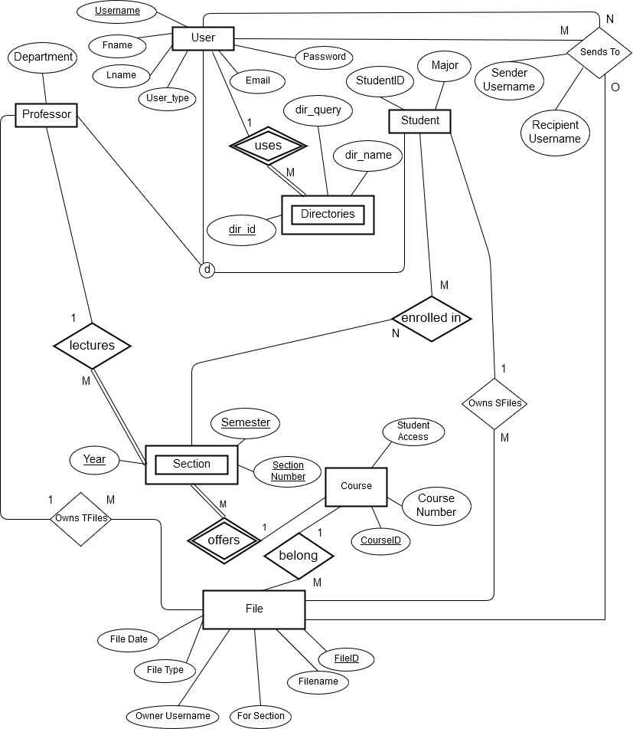

Object Oriented Model

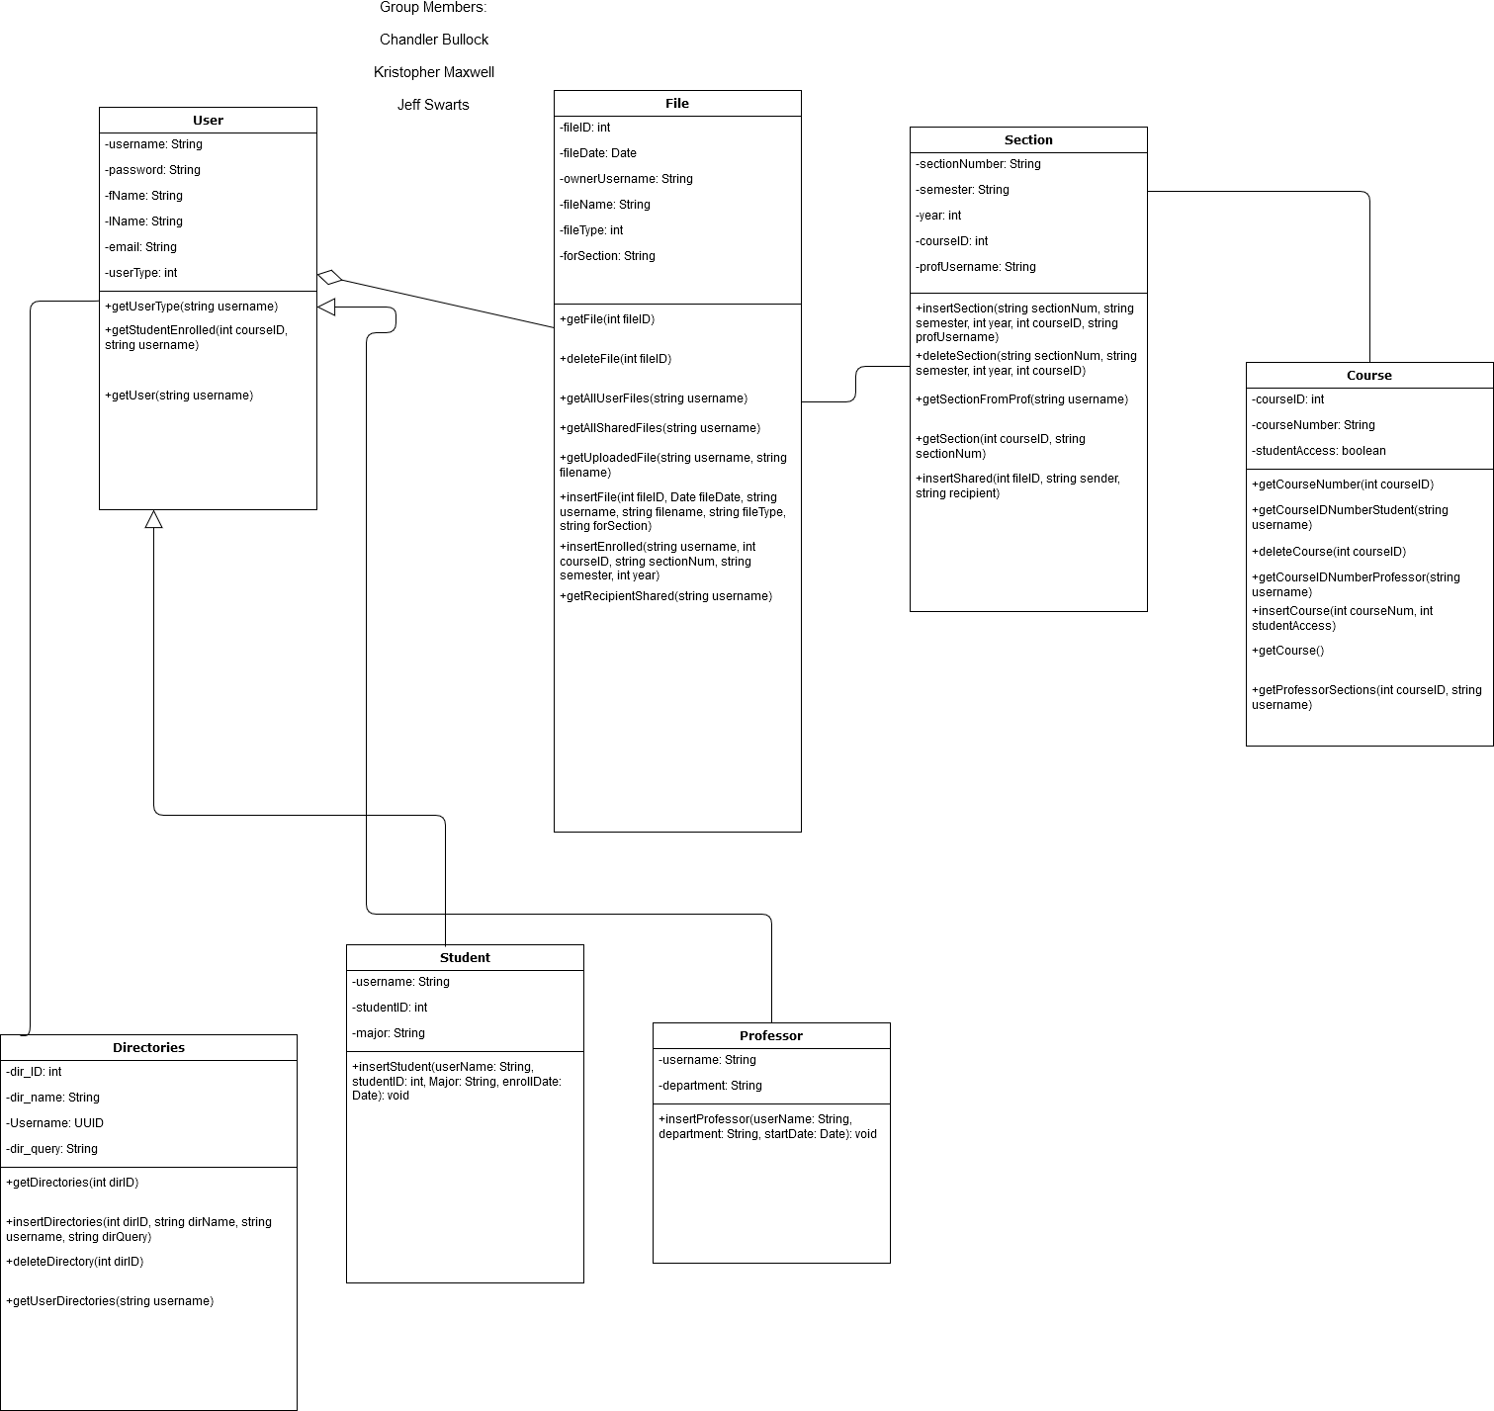

Relational Database Design

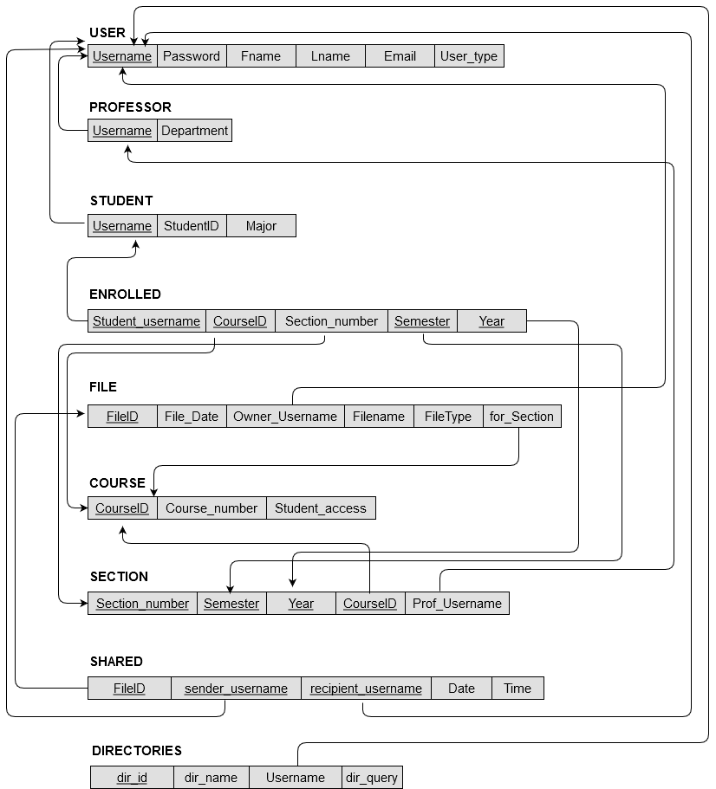

SQL Functions

File:

**getFile(int fileID):** select * from file where FileID=fileID;

**getFile(string owner):** select * from file where Owner_Username= owner;

**deleteFile(int fileID):** delete from file where FileID=fileID;

**getAllUserFiles(string username):** select * from file where Owner_Username=username;

**getAllSharedFiles(string username):** select * from shared natural join file where recipient_username=username;

**getUploadedFile(string username, string filename):** select * from file where Owner_Username=username and Filename=filename;

**insertFile(int fileID, Date fileDate, string username, string filename, string fileType, string forSection):** INSERT INTO file VALUES(fileID, fileDate, username, filename, fileType, forSection);

Directories:

**getDirectories(int dirID):** select * from directories where dir_ID = dirID;

**insertDirectories(int dirID, string dirName, string username, string dirQuery):** INSERT INTO directories values (dirID, dirName, username, dirQuery);

**deleteDirectory(int dirID):** delete from directories where dir_ID = dirID;

**getUserDirectories(string username):** select * from directories where Username = username;

Course:

**getCourseNumber(int courseID):** select Course_number from course where CourseID=courseID;

**getCourseIDNumberStudent(string username):** select distinct CourseID, Course_number from enrolled natural join course where Student_username=username;

**deleteCourse(int courseID):** Delete from course Where CourseID=courseID;

**getCourse():** select * from course;

**getCourseIDNumberProfessor(string username):** select distinct CourseID, Course_number from section natural join course where Prof_username=username;

**insertCourse(int courseNum, int studentAccess):** Insert into course (courseNum, studentAccess);

User:

**getUserType(string username):** select User_type from user where Username=username;

**getStudentEnrolled(int courseID, string username):** select * from enrolled where CourseID=courseID and Student_Username=username;

**getUser(string username):** Select * from user where Username=username;

Section:

**insertSection(string sectionNum, string semester, int year, int courseID, string profUsername):** Insert into section Values(sectionNum, semester, year, courseID, profUsername);

**deleteSection(string sectionNum, string semester, int year, int courseID):** Delete from section Where Section_number=sectionNum And Semester=semester And Year=year And CourseID=courseID;

**getSectionFromProf(string username):** select * from section where prof_username=username;

**getProfessorSections(int courseID, string username):** select * from section where CourseID=courseID and Prof_Username=username;

**getSection(int courseID, string sectionNum):** select * from section where CourseID = courseID and Section_number = sectionNum;

**insertShared(int fileID, string sender, string recipient):** Insert into shared Values(fileID, sender, recipient, CURDATE(), CURTIME());

**insertEnrolled(string username, int courseID, string sectionNum, string semester, int year):** INSERT INTO enrolled VALUES(username, courseID, sectionNum, semester, year);

**getRecipientShared(string username):** select * from shared natural join file where recipient_username=username;

**UniFile**

**User**

**Manual**

How to Navigate The School File Organizer

When you come to the login page there are two tabs. One allows you to register as a new user, the other allows you to sign in from an existing account. After completing either of these you will go to the main File page. To change users, or create a new account you can click the link on the top right. Any previously saved file directories are on the left. If you desire to add a file the option to do so is above the main file table. All other interactions are done through the file table and its immediate surroundings.

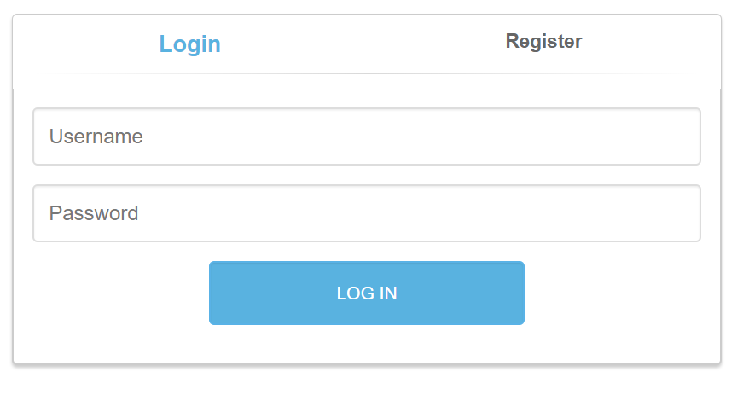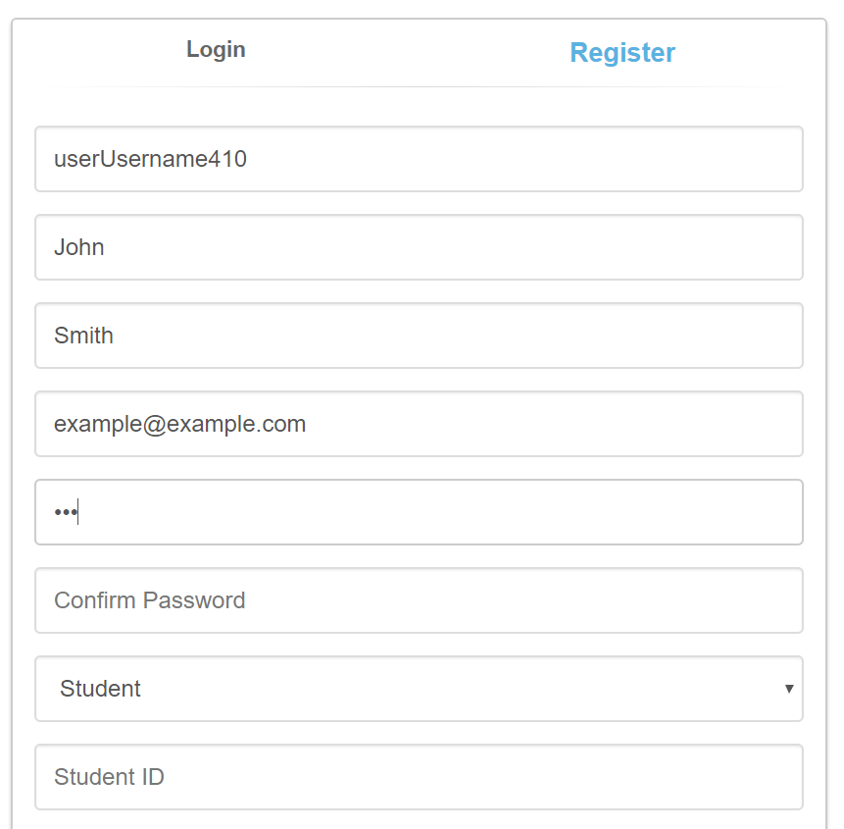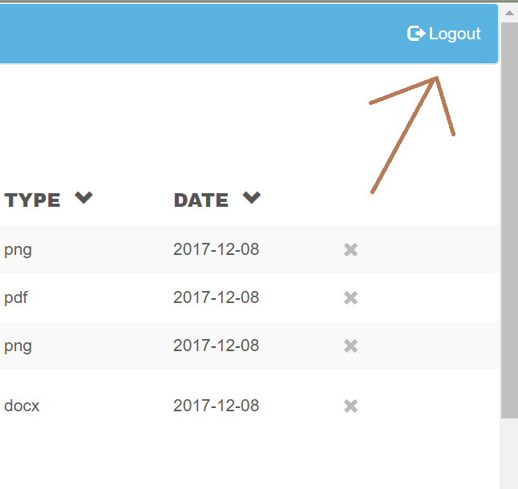

How to add files

Above the file table is a row that allows you to select a file from your local directory, and specify which course section the file is for. This will allow it to look up which professor teaches that specific section, The filename is generated from the name of the file on your local directory, and the day you upload the file is the date stamped on the file. The owner_username of a file will be set to your username.

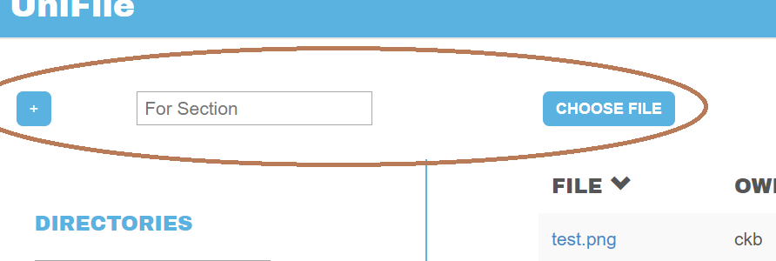

How to filter file list

If you wish to order the files by a specific attribute, you can click the down arrow that follows the table header for the attribute. This will group all like values for that attribute together. Doing several orderings with different attributes will preserve the original sorting of previous sortings where possible. If you wish to only show files that have a specific value for an attribute you may click on that value and it will eliminate all other file entries in your current view.

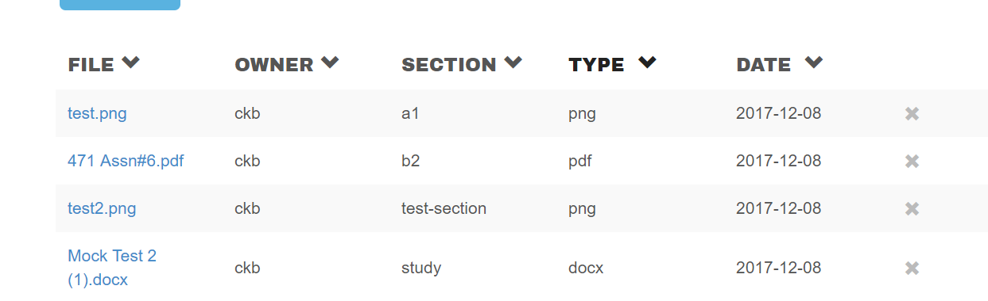

How to save the current view of files as a new directory

On the left of the main file page is a collection of your file directories, in that same section at the top is a textbox that allows you to specify a name for a new directory. This new directory will contain all the files in your current view. When you hit the save button the directory will be created.

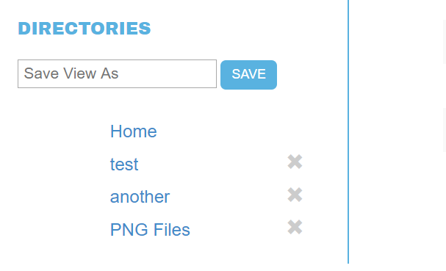

How to delete directories

To delete a directory move your cursor to the ‘x’ to the right of the directory you wish to delete clicking this will delete the specified directory.

How to share files

To the immediate left of each file is a share icon, after clicking this a modal box will pop up allowing you to specify a user you would like to share the file with. You must type their exact username.

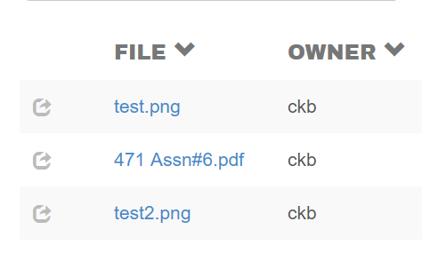

How to download files

You can download any file in your current view by clicking on the file name. This does not sort by attribute value like clicking on values of other columns does.

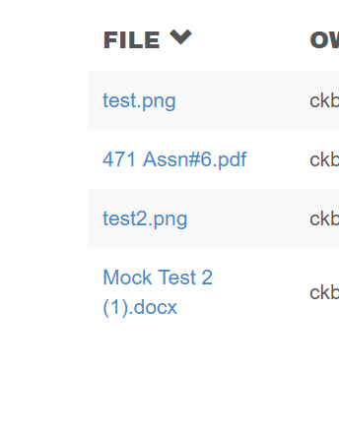

How to delete files

On the far right of each file entry is a trash icon, clicking this will ask for confirmation and then delete that file from your files, those whom you’ve shared it with will not be able to access it anymore.

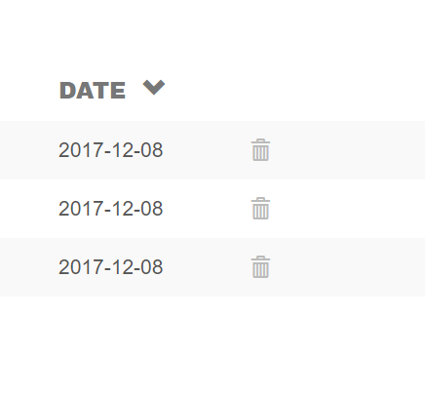

How to add a course or section (requires a professor account)

On the top right corner of the page, to the left of the Logout link, is the Manage Classes link. This link will take you to the Classes page. Here you can add new courses to the database, or add sections for existing courses. If you want to go back to the file page, click the Manage Files button in the top left corner to the left of Logout.

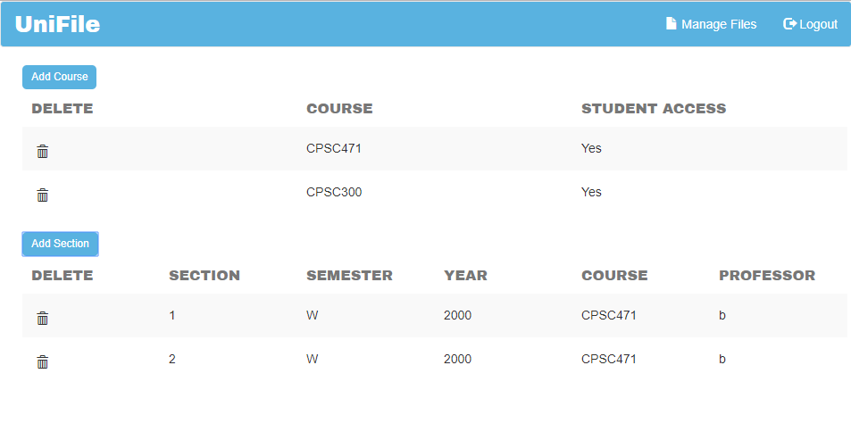

To add a new course, click on the Add Course button on the far left of the page, above the list of courses. This will open the Add Course prompt. After filling in the Course Number field, and checking whether students will have access to this page, click on Add Course to add the course, as long as the Course Number is unique. If you decide not to add a class, click Cancel.

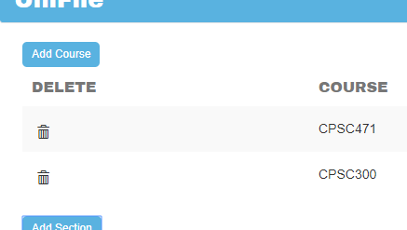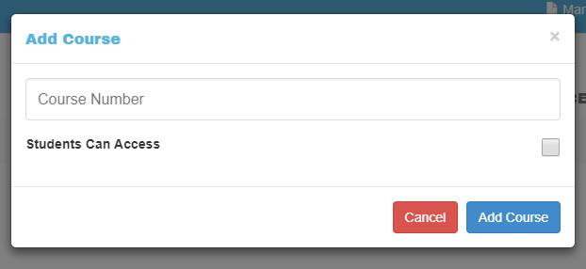

To add a new section, click on the Add Section button on the far left of the page, below the list of courses and above the list of sections. This will open the Add Section prompt. Fill in the Section Number, Semester, Year, and choose one of the existing courses, then click on Add Section to add the section. If you decide not to add a section, click Cancel.

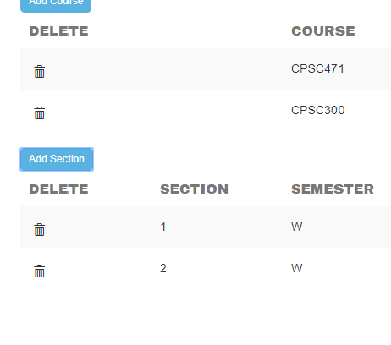

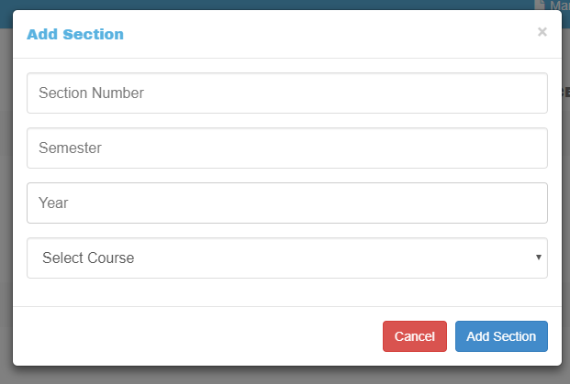

How to delete courses or sections

To delete a course or section, click on the trash can button next to the course or section in the table you want to delete.

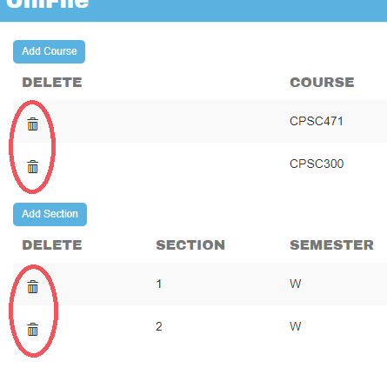

How to Enroll in a course and section (requires a Student account)

Students can enroll in a single section for a given course. To enroll in a course and section, click on the Enroll button, in the top right corner to the left of Logout. Here, you can select a course, then select a section for that course, then click the enroll button to enroll in that course and section. If you want to go back to the file page, click on the Manage Files button in the top right corner, to the left of the Logout button.

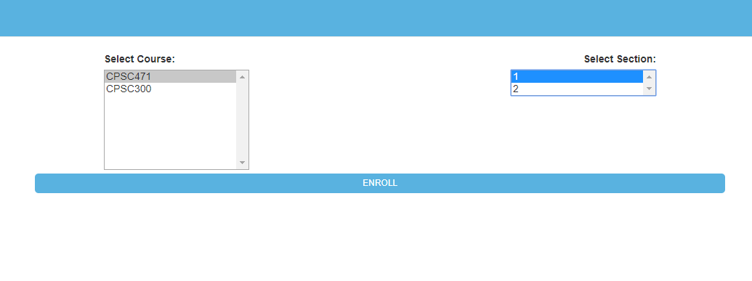

Appendix:

User:

|  |  |  |  |  |  |
| --- | --- | --- | --- | --- | --- |
| Username | Fname | Lname | Email | Password | User_type |
| student_1 | Bob | Smith | bob.email@email.com | bobpassword | 0 |
| student_2 | Sarah | Coleman | sarah@email.com | sarahpassword | 0 |
| student_3 | Rick | Nielson | rick@email.com | rickpassword | 0 |
| student_4 | Emily | Thatcher | emily@email.com | emilypassword | 0 |
| student_5 | Thomas | Wallace | thomas@email.com | thomaspassword | 0 |
| student_6 | Shirley | Jenson | shirley@emaiil.com | shirleypassword | 0 |
| prof_1 | John | White | john@email.com | johnpassword | 1 |
| prof_2 | Janelle | Morrison | janelle@email.com | janellepassword | 1 |

Course:

|  |  |  |
| --- | --- | --- |
| CourseID | Course_number | Student_access |
| 1 | CPSC471 | No |
| 2 | ENGL101 | Yes |
| 3 | GEOL202 | No |
| 4 | CPSC217 | Yes |
| 5 | ENG403 | No |
| 6 | SOCI101 | Yes |
| 7 | ARHI201 | No |
| 8 | PHIL279 | Yes |

Section:

|  |  |  |  |  |
| --- | --- | --- | --- | --- |
| Section_number | Semester | Year | CourseID | Prof_Username |
| 01 | Fall | 2017 | 1 | prof_1 |
| 02 | Winter | 2017 | 1 | prof_2 |
| 01 | Spring | 2017 | 2 | prof_1 |
| 02 | Summer | 2017 | 2 | prof_2 |
| 01 | Fall | 2017 | 3 | prof_1 |
| 02 | Winter | 2017 | 3 | prof_2 |
| 01 | Spring | 2017 | 4 | prof_1 |
| 02 | Summer | 2017 | 4 | prof_2 |
| 01 | Fall | 2017 | 5 | prof_1 |
| 02 | Winter | 2017 | 5 | prof_2 |
| 01 | Spring | 2017 | 6 | prof_1 |
| 02 | Summer | 2017 | 6 | prof_2 |
| 01 | Fall | 2017 | 7 | prof_1 |
| 02 | Winter | 2017 | 7 | prof_2 |
| 01 | Spring | 2017 | 8 | prof_1 |
| 02 | Summer | 2017 | 8 | prof_2 |

Student:

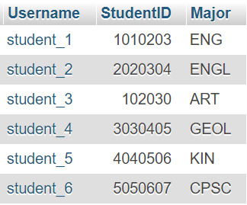

File:

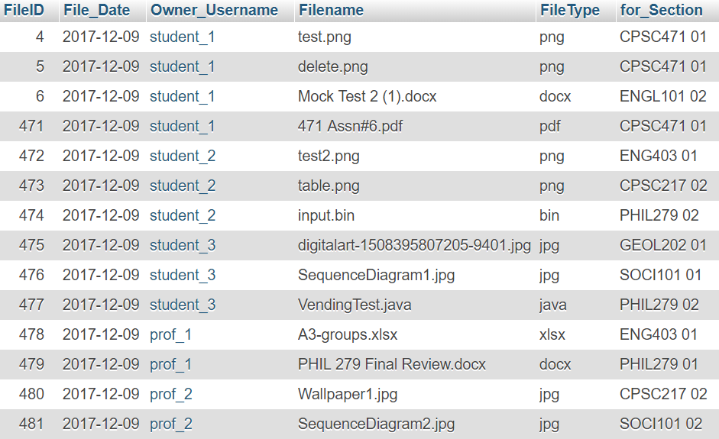

Enrolled:

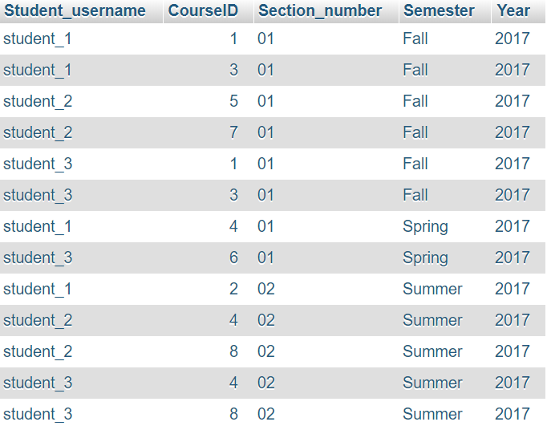

Professor:

|  |  |
| --- | --- |
| Username | Department |
| prof_1 | CPSC |
| prof_2 | ENGL |

Shared:

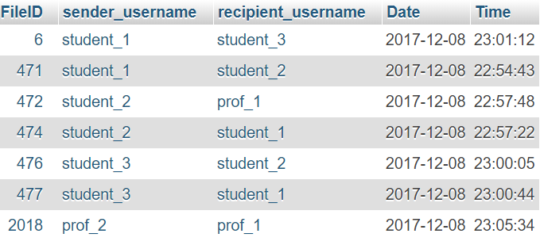

Directories:

